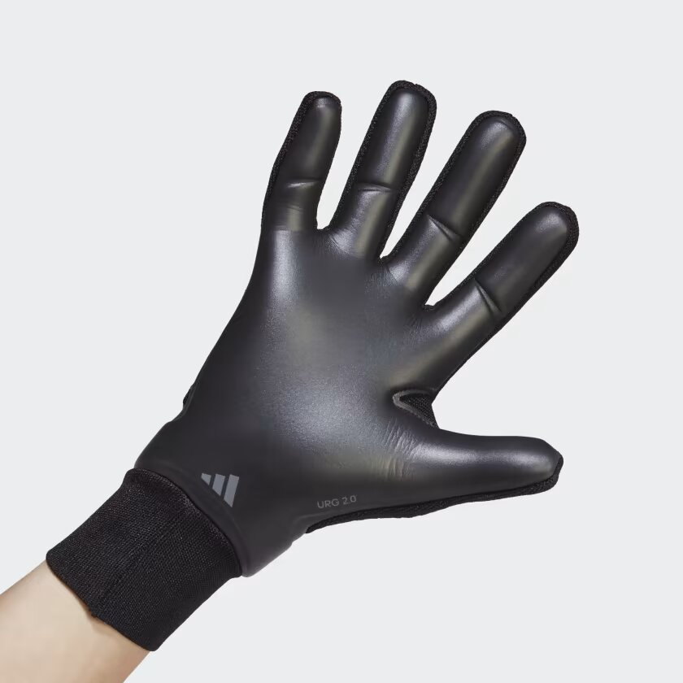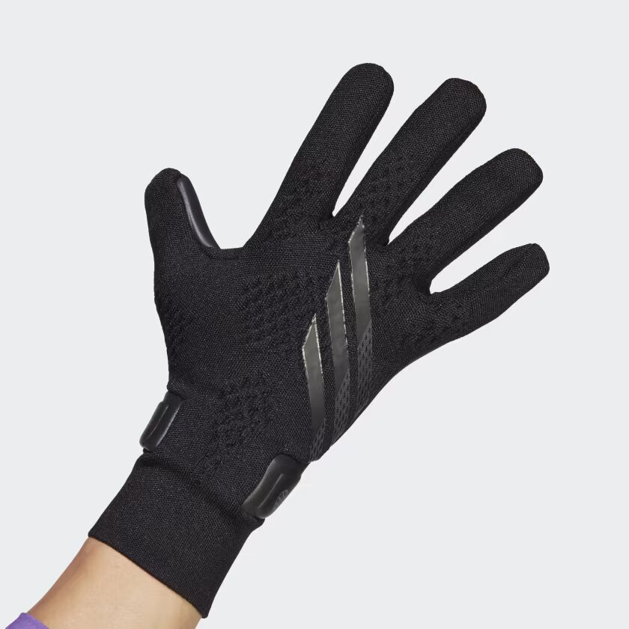

ADIDAS X SPEEDPORTAL PRO GLOVES

Unlock a new dimension of agility. These adidas X Speedportal goalkeeper gloves keep you quick with a lightweight, streamlined design. Their strapless, flexible knit backhand offers a locked-in fit thanks to an engineered cuff that wraps snugly around the wrist. On the outside, their URG 2.0 latex palm helps you grip the soccer ball and cushion fiercely struck shots. On the inside, non-slip silicone ensures you're at one with your gloves.

**DETAILS:**

* Negative cut
* Body: 91% polyester, 8% elastane, 1% nylon
* Palm: URG 2.0 100% rubber foam
* Engineered knit entry
* Snug-fitting engineered cuff
* Anti-slip palm
* Imported
* Product color: Black
* Product code: HN5567